

**TSDS Load Summary Reports**

TEA has provided a report (screen) at both the LEA level and the ESC level to view the Domains and Entities that have been loaded. The screen shows the **Domains**, **Entities**, and number of **Records**.

1. Log into **TEAL**.
2. Click on **Texas Student Data System Portal** link.

1. Click on **Manage IODS**.

1. On the **Data Management Center (DMC)** screen select View **Reports > Load Summary.**

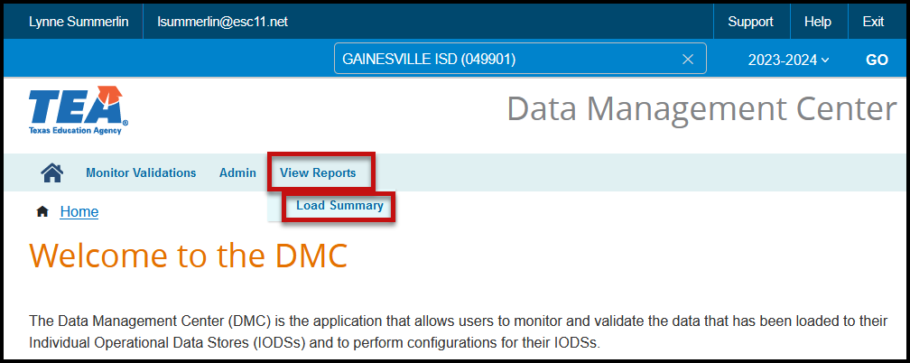

1. The **Load Summary** screen appears with the **Number of Domains Loaded for 2024-2025** and a list of those domains.

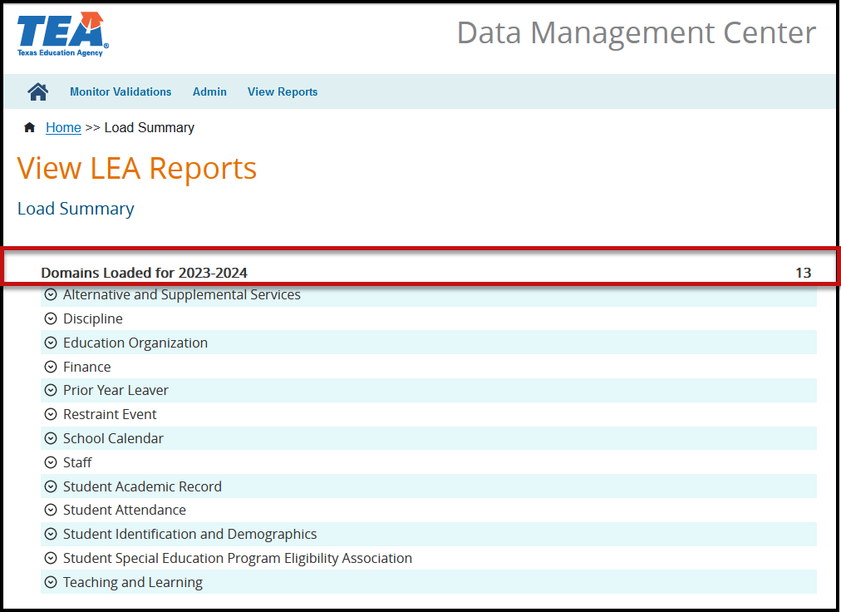

2024-2025

1. Each Domain listed can be expanded to show a list of the Entities loaded and the number of records loaded for each Entity.

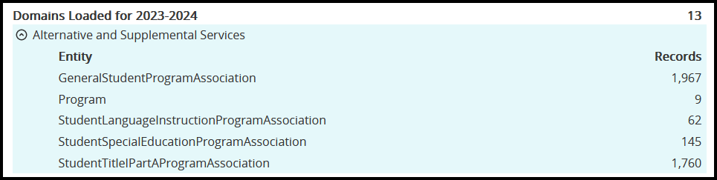

2024-2025

1. These numbers should be compared to your SIS to verify that all data is extracting correctly. Below is a list of the Domains that are utilized in the TSDS Upgrade Project.

A screenshot of a list of the Ed-Fi Domains



Limited Consent: ESC Region 11 grants permission to attendees of this session to reproduce and distribute designated resources and materials provided during the presentation.